Case Study Report
Case Study Introduction
In today’s digital age, consumers are relying more and more on e-commerce as the convenient, and sometimes the only, method to obtain goods and services. E-commerce already accounted for more than $600 billion in commercial profits before the coronavirus pandemic increased it to $861 billion. Due to the industry’s size, number of online competitors, and overwhelming similarities between the competitors, higher on-time delivery rates are often times the deciding factor in whether a customer stays with a business or churns; customers expect not only a quick product delivery time, they expect the company to be reliable with their estimates as well. Not meeting delivery estimates can lead to high levels of customer churn and difficulty obtaining new customers in the future.
This case study centers around one struggling online retailer, which can be called EC for the purpose of this study. EC specializes in selling electronic products and it sells products purely online. However, it has one key business problem: a very large percentage of its products end up delivered later than their estimated time of arrival. This is negatively impacting EC’s online reputation because customers expect a business to deliver according to time estimates. Data science presents a solution to their problem in the form of a classification model. Such a model can be trained to classify an input as one of many output categories based on a training dataset. In this case, a binary classification model can be constructed to predict which deliveries will be on-time or late. With such a model, EC can “catch” the deliveries predicted to be late, focus more of their resources on determining the cause of the delay, and perform the necessary corrective action to get back on their feet.

Dataset
EC has a dataset that can be used to train such a model. They have neatly recorded transaction information for each customer within a table, where each row represents one customer and each column represents information about the customer and their transaction, such as product price, weight, delivery method, origin warehouse, economic importance, and discounts offered, and customer inquiries, prior purchase number, rating, and gender (see Table 1) The data contains 11 features, only 2 of which are continuous. Consequently, a majority of the graphical analyses were categorical plots such as bar and pie charts.

Graphical Analyses
Before the model can begin to be constructed, a few graphs and graphical analyses must be conducted to gain insights about the dataset. First, histograms were constructed for all continuous variables to determine if any variables are heavily skewed, and it was found that percent discount is very right-skewed (see Figure 1). Because of this, a transformation must be applied to be able to use this variable. Then, pie charts were generated for all categorical variables to determine if imbalanced classes exist in the dataset. If such imbalanced classes do exist, then accuracy will not be used as a scoring metric, requiring precision and recall to be used instead to evaluate the classification model. As it turns out, many of the variables are imbalanced, including the target variable: on-time vs late delivery (40% of deliveries were late).
Once these graphs were constructed and analyzed, bar charts and histograms were set up for their respective variables separated by whether a product was on-time, in an attempt to find any apparent trends in delivery punctuality. Based on this, it appears that discount and product importance influence delivery punctuality (see Figure 2).
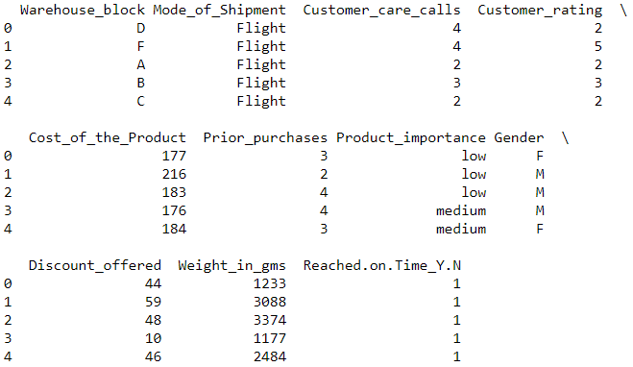
Table 1: The dataset that EC has collected on each customer transaction. It includes information about the product purchased and the customer who purchased the product.
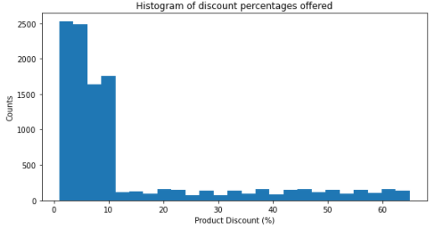
Figure 1: Most of the discounts offered by EC are at most 10%, heavily skewing this data column. This requires normalization using the log10 function to fix.

Figure 2: We can see that the on-time to late delivery ratio is much greater for low/medium importance products.

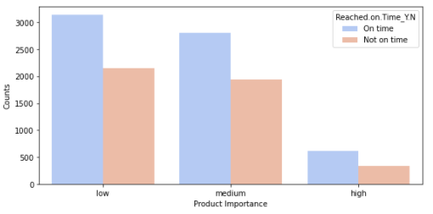

Dimensionality and Feature Reduction
Now that the dataset has been explored and visualized, its features must be curtailed. Several input features will make a classification problem much more difficult to model, so we must ensure the model is only using the features relevant to building the model. In addition, we must identify any input variables that are correlated with each other and remove one, as both will have the same effect on the output and reduce the predictive power of the model.
To accomplish feature reduction, a method known as Recursive Feature Evaluation (RFE) was used. This method constructs a model (in this case, logistic regression) and recursively eliminates input features until the best possible model performance is reached. A few data preparation steps must be conducted prior to running RFE, however.
First, the column of discounts offered is transformed with the log10 function as stated before, then a Pearson correlation heatmap is constructed of the variables to determine the correlations (see Figure 3). If two inputs are highly correlated (>0.3), one will be dropped. The discount column and log discount column were highly correlated, so discount was dropped in favor of log discount, which is less skewed.
With the correlations eliminated, a dummy dataframe was generated from the variables (i.e., each category of a categorical variable becomes its own feature) to be able to apply the RFE function. The RFE function indicated that the best features to keep are the log10 of discounts, the land category from methods of shipment, and the low/medium categories from product importance. These kept features were stored as their own data frame to be used in the coming steps.
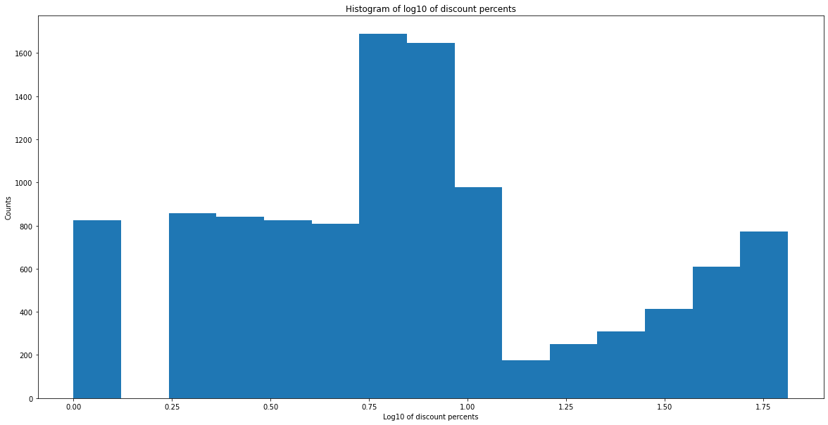
Figure 3: The log-transformed column of discounts offered by EC (left), and the heatmap of Pearson correlations (below). Compare the above to Figure 1 to see how the skewness is eliminated.

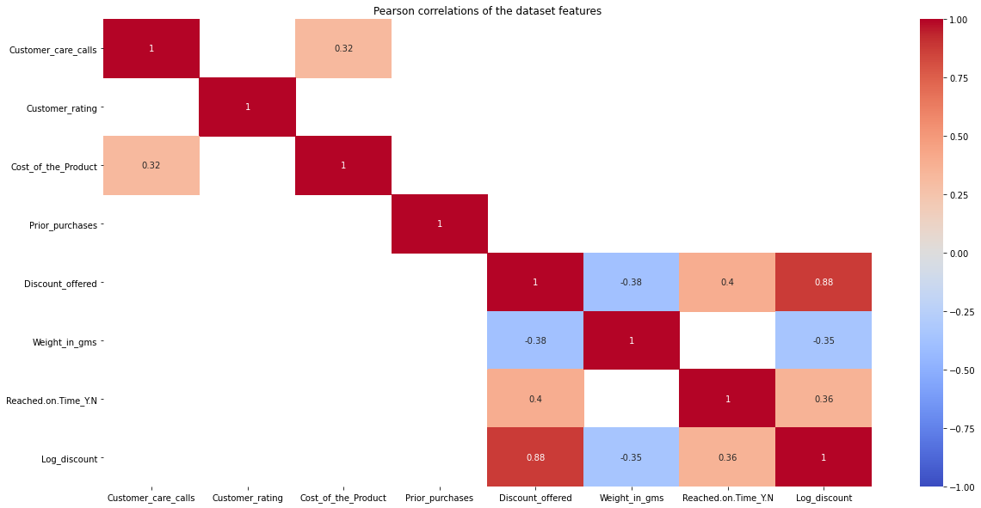
Model Building and Evaluation
Because the business problem is primarily one of binary classification, I trained a simple logistic regression model to fit the data. I used it in conjunction with repeated a k-fold cross-validation (KFCV) using 10 folds. The KFCV will split the data into 10 folds, 1 of which will be used as the testing fold. The testing fold will then be alternated until all folds have been used as the testing fold. This eliminates biases by ensuring that all the data is used for training and testing the model, not just a portion as in the train_test_split function.
The cross_val_score function was then used to train the model on the kept features and target data from Milestone 2. The aforementioned cross validation was used to split the data accordingly. This function also evaluated the trained model by outputting scoring metrics. One cross_val_score function is needed to output the precision and recall scores, with the F1 score being a harmonic mean of the former two.
The logistic regression model output precision, recall, and F1 scores of 65%, 76%, and 70%, respectively. This is much lower than I expected due to the use of logistic regression and repeated KFCV with 10 folds. In terms of the case study, this means that out of all the on-time predictions this model assigns, it can assign a correct on-time classification to a delivery about 65% of the time. Out of all the true on-time deliveries, it can guess which ones will be on-time about 76% of the time. The harmonic mean score was 70%. The fact that the highest score was still below 80% means that the default hyperparameters may not be working for the model. In the next step, the model hyperparameters will be tuned in an attempt to improve the model’s scoring metrics.

Hyperparameter Tuning
Hyperparameters are parameters that influence the training of a classification or regression model. Changing these parameters can have a large impact on the model’s scoring metrics; ergo, the hyperparameters that yield the highest scoring metrics must be used. Fortunately, there is a function that can accomplish just this, the GridSearchCV function. It can test a model on a specified range of multiple hyperparameters and return the specified score for each combination of hyperparameters. In addition to tuning using GridSearchCV, I also utilized the Synthetic Minority Oversampling Technique (SMOTE) to balance the target vector class fed to the function. This will allow me to use the accuracy score as well in this step, unlike the previous step.
First, I define the range of the 3 hyperparameters I want to test – solver, penalty, and C score – then I store them in a dictionary and run GridSearchCV on the logistic regression model using this dictionary. Much like cross_val_score, one GridSearchCV function is needed to calculate each score, resulting in 3 functions for accuracy, precision, and recall. I then proceed to fit the feature and target data, balanced by SMOTE, to each grid search function to generate the scores. At this point, there are 3 scores for each combination of hyperparameters, so I search for the best scores and print them out. The best scores turn out to be 62%, 70%, and 90% for the accuracy, precision, and recall, respectively. F1 was not calculated this time since it is just a mean value.
The precision and recall scores were much higher after applying SMOTE to the data and hyperparameter tuning to the model. The measured accuracy here was 62%, meaning all correctly identified on-time/late deliveries were 62% of identifications, nearly 2/3. However, out of all the on-time predictions the new model assigns, it can assign a correct on-time classification to a delivery about 70% of the time, and out of all the true on-time deliveries, it can guess which ones will be on-time more than 90% of the time. This new model is much better than the one from the previous part, but it is only good enough to help EC improve its online reputation, not to maintain a good reputation in the long run. This is because customers become more sensitive to late deliveries the higher the on-time delivery rate is. To maintain a good online reputation once it has been achieved, EC needs a model with all scoring metrics to be above 85%, perhaps even higher.

Conclusion
In the e-commerce industry, there are several similarities between online retailers. For example, Amazon, Costco, eBay, and Walmart all offer online marketplaces with many of the same goods, services, and features. Due to the overwhelming similarities between many retailers, higher on-time delivery rates are often times the deciding factor in how many customers churn. By developing a machine learning model that can “catch” late deliveries via predictions, resources can be allocated accordingly to remedy these late deliveries and improve a retailer’s on-time delivery rate. I believe a model with scoring metrics at least 85% would be ideal here.
After applying SMOTE to my logistic model and tuning its hyperparameters, I found that only the recall score was above 80%. This model may improve EC’s customer retention in the short term, as it is better than guessing what will constitute a late delivery, but it is not optimal for long-term customer retention. My recommendation is for EC to use this model as a temporary fix to their problem while models with better performance metrics are developed. This model will help them focus their resources to remedy the late deliveries and improve customer retention, but they should switch models as soon as they can to keep a good reputation.
Before EC can implement the current model, I must pitch the problem to stakeholders in order to gain the capital to proceed with implementation. I would pitch the business problem to a group of stakeholders via a presentation detailing the full business problem and the benefits of using this regression model as a solution. I would include the highest scoring metrics – 70% precision, 90% recall, and even the 81% resulting F1 score – to better convince stakeholders to invest in this solution, as well as the low cost of implementation. I would also include the earlier caveat to switch to a better model once their customer retention has improved past a certain point. By the time customer retention has improved enough, a new model will have been developed and tested.
In addition, there are a few obstacles to overcome. Selecting the right model that will ultimately replace the logistic regression is one obstacle that can be quite difficult to overcome due to the high scoring metrics required for this case study. Training and testing must be done on several models to find the optimal one for permanent use, which will require much time. I am confident, though, that a better model can be built and trained to keep EC alive and well in the near future.

References
Brownlee, J. (2019). Tune Hyperparameters for Classification Machine Learning Algorithms. Machine Learning Mastery. Retrieved on June 2, 2021 from https://machinelearningmastery.com/hyperparameters-for-classification-machine-learning-algorithms/.
Evans, K. (2021). US ecommerce grows 44.0% in 2020. Digital Commerce 360. Retrieved on June 2, 2021 from https://www.digitalcommerce360.com/article/us-ecommerce-sales/.
Gonzales, M. (2016). Delivery Time Top Priority for Online Shoppers. Material Handling and Logistics. Retrieved on June 2, 2021 from https://www.mhlnews.com/transportation-distribution/article/22051729/delivery-time-top-priority-for-online-shoppers.
Gopalani, P. (2021). E-Commerce Shipping Data. Kaggle. Retrieved on June 2, 2021 from https://www.kaggle.com/prachi13/customer-analytics.
Ly, C. (2015). The Importance of On-time Order Delivery For E-commerce Business. Medium. Retrieved on June 2, 2021 from https://medium.com/@lycth/the-importance-of-on-time-order-delivery-for-e-commerce-business-2db3c91681ee.
Navlani, A. (2019). Understanding Logistic Regression in Python. Datacamp. Retrieved on June 2, 2021 from https://www.datacamp.com/community/tutorials/understanding-logistic-regression-python.

